|  |  |
| --- | --- |
| **Ex.** 1 | **ELECTRICITY BILL GENERATION** |
| **Date:** 19-07-2024 | |

**AIM:**

To develop a Java application that generates an electricity bill based on the type of EB connection and the amount of electricity consumed in the previous and current cycle.

**ALGORITHM:**

1. Create a class and define the members of the class.
2. Receive the inputs from the user during the runtime.
3. Initialise the values of the members of the class using the constructor method.
4. Compute the total bill based on the connection type.
5. Display the bill generated.

**PROGRAM:**

// Program to Implement an EB Bill Generator using Java.

import java.util.Scanner;

public class lab1

{

// Objects in Class

int consumerNumber;

String consumerName;

double previousMonthReading;

double currentMonthReading;

boolean type;

// Constructor Method to Initialise

public lab1(int consumerNumber, String consumerName, double previousMonthReading, double currentMonthReading, boolean type)

{

this.consumerNumber = consumerNumber;

this.consumerName = consumerName;

this.previousMonthReading = previousMonthReading;

this.currentMonthReading = currentMonthReading;

this.type = type;

}

// Method to Calculate Bill when it is Domestic Type

double domestic(double previousMonthReading, double currentMonthReading)

{

double ans = 0;

/* First 100 - 1

101-200 units - Rs. 2.50 per unit

201 -500 units - Rs. 4 per unit

501 units - Rs. 6 per unit */

double arr[] = {previousMonthReading, currentMonthReading};

for(int i=0;i<2;i++)

{

// First 100

if(arr[i] > 100)

{

ans += 100;

}

else

{

ans += arr[i];

}

// 100 - 200

if(arr[i] > 200)

{

ans += (2.5*100);

}

else

{

ans += ((arr[i]-100)*2.5);

}

// 200 - 500

if (arr[i]>500)

{

ans += (4*300);

}

else

{

ans += ((arr[i]-200)*4);

}

// > 500

if (arr[i] > 500)

{

ans += ((arr[i]-500) * 6);

}

}

return ans;

}

// Method to Calculate Bill when it is Commercial Type

double commercial(double previousMonthReading, double currentMonthReading)

{

double ans = 0;

/* First 100 - 2

101-200 units - Rs. 4.50 per unit

201 -500 units - Rs. 6 per unit

501 units - Rs. 7 per unit */

double arr[] = {previousMonthReading, currentMonthReading};

for(int i=0;i<2;i++)

{

// First 100

if(arr[i] > 100)

{

ans += 200;

}

else

{

ans += (arr[i]*2);

}

// 100 - 200

if(arr[i] > 200)

{

ans += (4.5*100);

}

else

{

ans += ((arr[i]-100)*4.5);

}

// 200 - 500

if (arr[i]>500)

{

ans += (6*300);

}

else

{

ans += ((arr[i]-200)*6);

}

// > 500

if (arr[i] > 500)

{

ans += ((arr[i]-500) * 7);

}

}

return ans;

}

// Main Method

public static void main(String args[])

{

Scanner input = new Scanner(System.in);

System.out.println("Enter the Consumer Number : ");

int num = input.nextInt();

System.out.println("Enter the Consumer Name : ");

String name = input.next();

System.out.println("Enter the Previous Month Reading : ");

double prev = input.nextDouble();

System.out.println("Enter the Current Month Reading : ");

double curr = input.nextDouble();

System.out.println("Enter True, if the Type of Connection is Domestic. Else, Enter False: ");

boolean type = input.nextBoolean();

lab1 billGenerated = new lab1(num, name, prev, curr, type);

if (billGenerated.type == true)

{

System.out.println(billGenerated.domestic(prev, curr));

}

else

{

System.out.println(billGenerated.commercial(prev, curr));

}

}

}

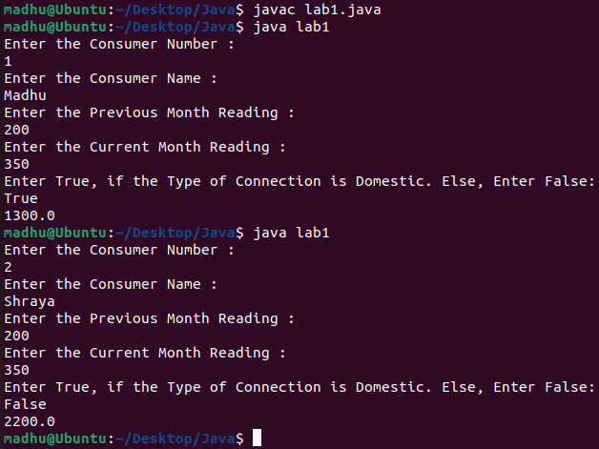**OUTPUT:**

**RESULT:**

Thus, a Java application to calculate and display the electricity bill for a consumer based on the type of EB connection (domestic or commercial) and the number of units consumed is successfully created.